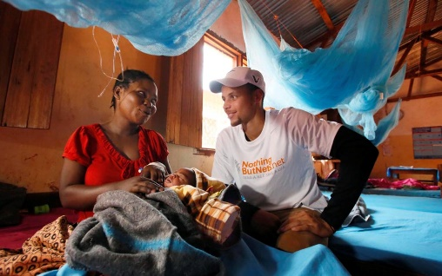
I've never asked for anything before, right? Well, sorry, I'm asking now.
We need nets.
Not hoop nets, soccer nets or lacrosse nets. Not New Jersey Nets or dot-nets or clarinets. Mosquito nets.
See, nearly 3,000 kids die every day in Africa from malaria. And according to the World Health Organization, transmission of the disease would be reduced by 60% with the use of mosquito nets and prompt treatment for the infected.
Three thousand kids! That's a 9/11 every day!
Put it this way: Let's say your little Justin's Kickin' Kangaroos have a big youth soccer tournament on Saturday. There are 15 kids on the team, 10 teams in the tourney. And there are 20 of these tournaments going on all over town. Suddenly, everyone of these kids gets chills and fever, then starts throwing up and then gets short of breath. And in seven to 10 days, they're all dead of malaria.
We gotta get these nets. They're coated with an insecticide and cost between $4 and $6. You need about $10, all told, to get them shipped and installed. Some nets can cover a family of four. And they last four years. If we can cut the spread of disease, 10 bucks means a kid might get to live. Make it $20 and more kids are saved.
So, here's the ask: If you have ever gotten a thrill by throwing, kicking, knocking, dunking, slamming, putting up, cutting down or jumping over a net, please go to a special site we've set up through the United Nations. The address is:UNFoundation.org/malaria. Then just look for the big SI's Nothing But Net logo (or call 202-887-9040) and donate $20. Bang. You might have just saved a kid's life.
Or would you rather have the new Beastie Boys CD?
You're a coach, parent, player, gym teacher or even just a fan who likes watching balls fly into nets, send $20. You saved a life. Take the rest of the day off.
You have ever had a net in the driveway, front lawn or on your head at McDonald's, send $20. You ever imagined Angelina Jolie in fishnets, $20. So you stay home and eat on the dinette. You'll live.
Hey, Dick's Sporting Goods. You have 255 stores. How about you kick in a dime every time you sell a net? Hey, NBA players, hockey stars and tennis pros, how about you donate $20 every time one of your shots hits the net? Maria Sharapova, you don't think this applies to you just because you're Russian? Nyet!
I tried to think how many times I have said or written the word "net" in 28 years of sports writing, and I came up with, conservatively, 20,000. So I've already started us off with a $20,000 donation. That's a whole lot of lives. Together, we could come up with $1 million, net. How many lives would that save? More than 50 times the population of Nett Lake, Minn.
I know what you're thinking: Yeah, but bottom line, how much of our $1 million goes to nets? All of it. Thanks to Ted Turner, who donated $1 billion to create the U.N. Foundation, which covers all the overhead, "every cent will go to nets," says Andrea Gay, the U.N. Foundation's Director of Children's Health.
Nets work! Bill and Melinda Gates have just about finished single-handedly covering every bed in Zambia. Maybe we can't cover an entire Zambia, but I bet we could put a serious dent in Malawi.
It's not like we're betting on some scientist somewhere coming up with a cure. And it's not like warlords are going to hijack a truckload of nets. "Theoretically, if every person in Africa slept at night under a net," says Gay, "nobody need ever die of malaria again." You talk about a net profit.
My God, think of all the nets that are taken for granted in sports! Ping-Pong nets. Batting cage nets. Terrell Owens's bassinet. If you sit behind the plate at a baseball game, you watch the action through a net. You download the highlights on Netscape and forward it on the net to your friend Ben-net while eating Raisinets. Sports is nothing but net. So next time you think of a net, go to that website and click yourself happy. Way more fun than your fantasy bowling league, dude.
One last vignette: A few years back, we took the family to Tanzania, which is ravaged by malaria now. We visited a school and played soccer with the kids. Must've been 50 on each team, running and laughing. A taped-up wad of newspapers was the ball and two rocks were the goal. Most fun I ever had getting whupped. When we got home, we sent some balls and nets.
I kick myself now for that. How many of those kids are dead because we sent the wrong nets?

