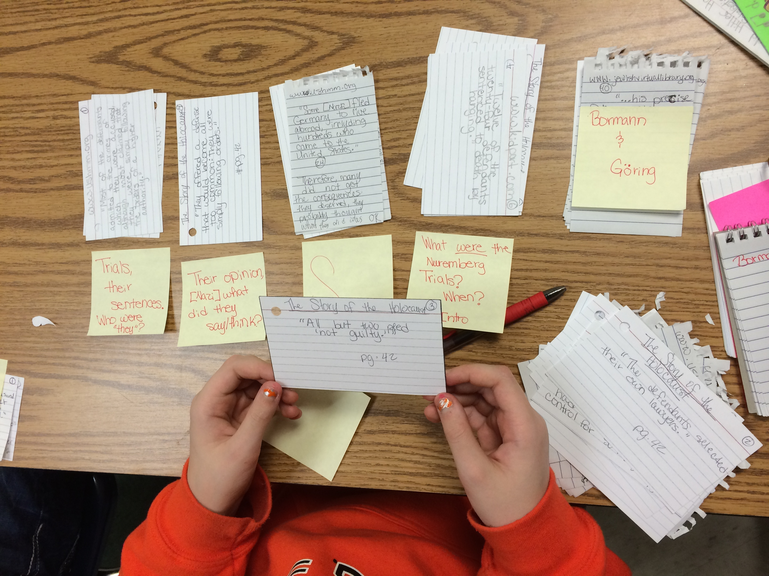
Organize Notes

- Step 1: double check all note cards, and make sure they have the source written on top!
- Step 2: take note cards off of ring and sort into 6 main ideas/sub-topics
  - Example: topic = Anne Frank
    - early years
    - family
    - life in hiding
    - her diary
    - captured/concentration camp/death
    - her legacy
- Step 3: if you notice that you do not have enough information under certain sub-topics, you may need to do some more research!
- Step 4: begin outline (see outline page)

Organize Notes

- Step 1: double check all note cards, and make sure they have the source written on top!
- Step 2: take note cards off of ring and sort into 6 main ideas/sub-topics
  - Example: topic = Anne Frank
    - early years
    - family
    - life in hiding
    - her diary
    - captured/concentration camp/death
    - her legacy
- Step 3: if you notice that you do not have enough information under certain sub-topics, you may need to do some more research!
- Step 4: begin outline (see outline page)

